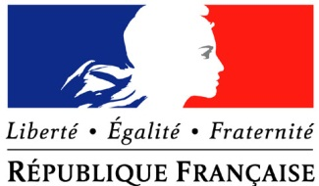

Visit of Gérard ARAUD

Ambassador of France in the USA
______

San Francisco, April 29th – May 2nd 2015
______
Program

April 29th
- Ubi i/o (a 10-week program, organized by Business France and Bpifrance, will allow 8 companies to participate in an accelerated immersion in the Silicon Valley’s ecosystem) opening party – Keynote, pitch sequence, networking cocktail

April 30th
- Lunch at Faculty club – Berkeley, organized by Larry Hyman, Executive Director, France-Berkeley Fund)
- Interview with Edwin M. Lee, Mayor of the City and County of San Francisco
- Visit of the French consulate in San Francisco + Business France offices
- Photography exhibition / cocktail hosted at La Résidence de France in San Francisco (artist: Arnaud Gaertner ; about: Burning Man – Nevada)

May 1st
- Conference at Stanford University
- Gérard ARAUD will visit Cleantech companies in Silicon Valley
- French business community party at La Résidence de France in San Francisco

May 2nd
- Press breakfast in San Francisco, at Café de la Presse

